

Kingdom of Saudi Arabia Ministry of Education Prince Sattam bin Abdul-Aziz University College of Computer Engineering and Sciences software engineering department

**ةيدوعسلا ةيبرعلا ةكلمملا**

**ميلعتلا ةرازو**

**زيزعلادبع نب ماطس ريملأا ةعماج**

**بساحا مولعو ةسدنه ةيلك**

**تايجمرب ةسدنه مسق**

**Project**

**Tawakkalna System**

|  |  |  |
| --- | --- | --- |
| **N** | **Student Name** | **Student Number** |
|  | Riyadh Awad AlRasheedi | 441051688 |
|  | Musaed Bader Alharbi | 442051641 |
|  | Sulaiman Mohammed AlSubaie | 442051773 |

**Supervised by:** Dr.Mohammed Al-Asiri

**Year:**



**Group Project Proposal**

**Introduction**

With the widespread spread of the Covid-19 virus around the world, countries have tried to adopt various methods to combat the Covid-19 epidemic, such as quarantine and self-isolation. Although this has proven effective to some extent, it has negative effects on the national economy and the intensive effort. Therefore, we suggested making an application that helps the Saudi government limit the spread of the Corona virus. It aims to track cases, save lives and reduce the burden on health facilities to help prevent the spread of COVID-19.

**Problems**

The COVID-19 pandemic has had multifaceted impacts - not only on people's health and well-being but also on the economic and social spheres. The COVID-19 pandemic has intensified the need for digital technologies to provide accessible, inclusive and value-added public services to all citizens.

**Background**

We have developed the mobile application to be a solution to prevent the outbreak of the Coronavirus. The application has a range of features, including contact tracing, permit applications, compliance with official guidelines and regulations, and real-time updates on the spread of the virus. Users can use the app to request passes for activities such as going to work, shopping, or attending medical appointments, and the app provides real-time updates on user compliance with official guidelines and regulations.

**|** P a g e **1** Software Engineering Project - SE 3101



**Proposed solution**

We have developed a COVID-19 app called Tawakkalna, to support government activities in response to the pandemic. The application provides services to facilitate COVID tests in terms of submitting a request through the application to conduct the examination and choosing the appropriate time and place to conduct the examination. It also provides permit services to enter gatherings, which helps reduce crowding and prevent the spread of the virus, which reduces the burden on the government.

**Work Plan**

Task Days Start End Responsible Status

Introduction 2 27/4 28/4 **Complete**

problem 2 29/4 30/4 **Complete**

Background 2 1/5 2/5 **Complete**

Proposed approach 3 3/5 5/5 **Complete**

Work plan 2 6/5 7/5 **Complete**

Functional

requirements

2

9/5

10/5

**Complete**

Non-functional

requirements

2

11/5

12/5

**Complete**

Project activity

model

3

13/5

15/5

**Complete**

Project use case

modelling

3

16/5

18/5

**Complete**

Creating a class

diagram

2

19/5

20/5

**Complete**

Creating sequences

diagram

2

21/5

22/5

**Complete**

Report 1 23/5 23/5 **complete**

Presentation 1 24/5 24/5 **complete**

Context diagram 2 25/5 26/5 **complete**

**2 |** P a g e Software Engineering Project - SE 3101



**Project requirements**

•   **Functional requirements**

There are many functional requirements for our application and they are as follows.

a) functional user requirements:

1. The user should be able to log in to their account using their ID number

and password.

2. The user should be able to check in to a gathering by scanning a QR

code.

3. The user should be able to preview their Gathering Entry Permit.

4. The user should be able to sign-out from a gathering.

b) functional system requirements:

5. The system must authenticate users based on their ID number and

password.

6. The system must be able to recognize and verify QR codes.

7. The system must be able to generate and display Gathering Entry

Permits.

8. The system must update attendance records when a user signs-out from a gathering.

**3 |** P a g e Software Engineering Project - SE 3101



•   **non-functional requirements**

There are many non-functional requirements for our application as follows.

a) Non-functional user requirements:

1) Performance: The system must be able to handle a large number of

users simultaneously without slowing down or crashing.

2) Security: The system must be secure, with access controls and

encryption to protect user data and prevent unauthorized access.

3) Availability: The system must be available 24/7, with minimal downtime

for maintenance or upgrades.

4) Usability: The system must be easy to use and navigate, with clear and

intuitive interfaces.

b) Non-functional user requirements:

1) Performance: The user expects the system to respond quickly to their

actions, with minimal lag or delay.

2) Security: The user expects their personal data to be kept secure and

confidential, with appropriate access controls and encryption.

3) Availability: The user expects the system to be available whenever they

need it, without downtime or maintenance disruptions.

4) Usability: The user expects the system to be easy to use and navigate,

with clear and intuitive interfaces that require minimal training.

.

**4 |** P a g e Software Engineering Project - SE 3101

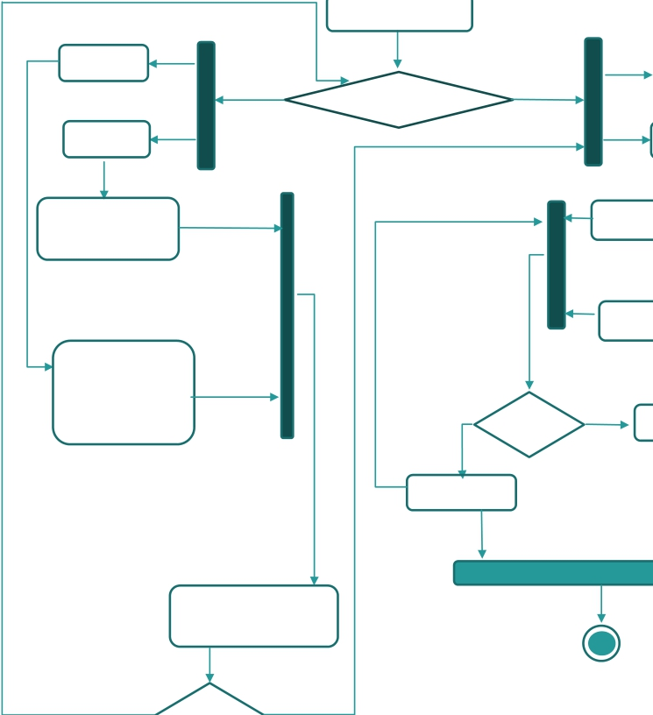

**Activity diagram**

1. **Registration or Login process**

Start point

Open the application

**visitor\GCC**

**citizen**

**Register**

**Login**

**visitor\GCC citizen**

**Registration or Login**

**Citizen/Resi**

**dent**

Fill-in the required info National/Iqama Number Date of Birth

Fill in the required information Passport\GCC ID number

**Citizen/Resi**

**dent**

Enter National/Iqama Number and password

Enter Passport\GCC ID number Nationality and password

Nationality Date of birth Phone number

No

Login valid

Yes

Main Screen

Display wrong

Enter the verification code sent to you via SMS

Enter a password and confirm

End point

No Yes

verification code

**5 |** P a g e Software Engineering Project - SE 3101

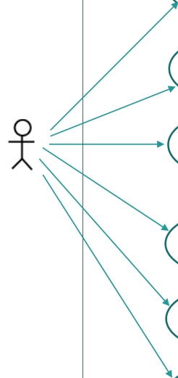

**Project Use Case Modelling**

**Use cases in the Tawakkalna system involving the role ‘Users’**

Asks for help.

Preview the testing results.

preview personal permit

**User**

preview gathering permits

book a covid_19 testing

Cancel covid_19 testing

**6 |** P a g e Software Engineering Project - SE 3101

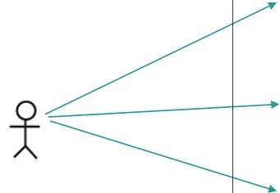

**Use cases in the Tawakkalna system involving the role ‘Health authorities’**

**Obtain user information**

**Granting permissions**

**To users through the application**

**Health authorities**

**Giving test res**ults to users through the application

**7 |** P a g e Software Engineering Project - SE 3101



**U-P-R:** Preview the testing results.

**Actors** **Users, System Tawakkalna**

**Description**

The user opens the "Tawakkalna" application and logs in. If a user wishes to get a test result, the user goes to the 'Coronavirus test results' section of the app. The Tawakkalna application retrieves the results of user tests from the competent health authority. Tawakkalna application shows the user the results of the user test.

Data Test results

Stimulus

" The app issues an order on behalf of the user through their phone. The results provided to the user through the app are directed by the relevant health authorities."

Response No response.

Comments The user must have an account in the Tawakkalna application.

**8 |** P a g e Software Engineering Project - SE 3101



**U-T-P: Take permits**

**Actors** **Users, System Tawakkalna**

**Description**

The user opens the "Tawakkalna" application and logs in.

If he wants to obtain a permit to enter a compound, he goes to the permits section, then submits a permit application.

The application sends the request to the health centers and the centers that respond with acceptance or rejection, and then gives it to the user.

.

Data Test results, User data

Stimulus

"The application issues a command on behalf of the user through their phone. The permits submitted to the user through the application are directed by the competent health authorities."

Response The request is under processing.

Comments The user must have an account in the Tawakkalna application.

**9 |** P a g e Software Engineering Project - SE 3101



**Creating Sequence Diagram**

**Sequence diagram for Register**

Registrar

Type

Registration

interface

Verify

registration

Password

interface

Database

twakklna

| | | |

| | | | |

| | | | |

| | | | |

Re(RT==1)

Re(RT==2)

Rinser(National/Iqama Number,DateBirth)

Rinesr(Passport\GCC ID number, Nationality, DateBirth, Phone number)

auth(usid,infro)

auth(usid,infro)

**<----------------** Send Code sms

passauth(pa

ssw)

**<---------------**

Error(leaspa

sw)

Sav(inf,

uid)

**<-----------**

Successful

Successful

[Register ok] **<----------------**

_ _ _ _ _ _ _ _ _ _ _ _ _ _ _ _ _ _ _ _ _ _ _ _ _ _ _ _ _ _ _ _ _ _ _ _ _ _ _ _ _ _ _ _ _ _ _ _

[Register Allow **<----------------**

Error(massage)

**10 |** P a g e Software Engineering Project - SE 3101



Creating Class Diagram

User_regiseter

Services

- National_Iqama_Number:int - Day_Birth:date

- Passport_GCC_ID_number:int

- Nationality:string

- PhonNumber:int -password:string

-id_process:int

+Adregi_natIq(Nat_Iqa_Num int,D_pirth date

,pass string)

+Adregi_ Paspt(Paspt_GC_ID_nu int, Nati string, D_Birth date, PhNu int, pass string)

1

-servId:int -servName:string

+addserv(serid

int,serNname string) +deletServ(serid int)

1

1 +delUsevist(string

Nat_Iqa_Num )

+delUse Paspt(PasptGC_ID_nu int )

Verification_regester

M

**GetServes**

**-idproc: Competent _authorities**

**servId:Services iduser: US_regis**

+Checkintoagathering (uid int,Cathid int,QR ,served int)

+PrevGathEntPer(uid int

N

N

1

-idvereg:int

,Servid int ,Cathid int)

+ ChoutfGather(uid int

,Servid int ,Cathid int)

+sendna_paC(Code string,usid)

+ResvCit()

+GatheringPermits(uid int ,served int)

Competent _authorities

-NameCA:String

-idCAu:string -locaC_auth:string

+addCau(name string,id string,location string )

+delCau(idCau string)

1

**11 |** P a g e Software Engineering Project - SE 3101